EXPT NO: 9 | TEXT CLASSIFICATION AND TEXT GENERATION USING TRANSFORMERS
DATE: 02.11.2026 | TEXT CLASSIFICATION AND TEXT GENERATION USING TRANSFORMERS

PRE-LAB QUESTIONS (PROVIDE BRIEF ANSWERS TO THE FOLLOWING QUESTIONS)

- What is a Transformer model in Natural Language Processing (NLP)?
Ans: A Transformer is a neural network architecture built on self-attention, which lets every token in a text weigh its relationship to every other token. It processes whole sequences in parallel and captures long-range context, and it is the basis of models such as BERT, GPT and T5.
- What is BERT, and how is it used for text classification?
Ans: BERT (Bidirectional Encoder Representations from Transformers) is a pretrained Transformer encoder that reads text in both directions. For classification, a small linear layer is added on top of the special [CLS] token representation, and the model is fine-tuned on labelled data (e.g. positive / negative reviews) so that it predicts the class.
- What is fine-tuning in the context of pretrained language models?
Ans: Fine-tuning continues the training of a model that was already pretrained on large text collections, using a smaller task-specific labelled dataset and a small learning rate. It transfers general language knowledge to the new task, so good results need much less data, time and compute than training from scratch.
- What is the difference between text classification and text generation?
Ans: Text classification assigns an input text to one label from a fixed set (e.g. positive/negative) and is evaluated with accuracy or F1. Text generation produces new text token by token (e.g. a summary or translation), so its output is open-ended and judged on relevance, fluency and coherence.
- What is a sequence-to-sequence model, and how is it used in text generation?
Ans: A sequence-to-sequence (seq2seq) model maps an input sequence to an output sequence of possibly different length. An encoder reads and encodes the input, and a decoder generates the output one token at a time. It is used for summarization, machine translation and question answering; T5 is an example.
AIM
To implement text classification by fine-tuning a pretrained BERT model and develop a simple sequence-to-sequence text generation application using Transformer models.

SOFTWARE REQUIREMENTS
- Python
- Google Colab
- Hugging Face Transformers
- Hugging Face Datasets
- PyTorch
- NumPy
- Pandas
- Matplotlib

OBJECTIVES
Students will be able to:
- Understand the architecture and working of Transformer models in NLP.
- Understand the concepts of text classification and text generation.
- Load and preprocess text datasets for NLP applications.
- Fine-tune a pretrained BERT model for text classification.
- Evaluate the classification model using appropriate performance metrics.
- Implement a sequence-to-sequence application using a pretrained Transformer model.
- Generate text using the model's text generation capabilities.
- Analyze and compare the outputs produced by the Transformer models.

PROCEDURE
PART A: DATASET PREPARATION AND TEXT PREPROCESSING
Perform the following tasks:
- Load a text dataset such as the IMDb movie review dataset.
- Explore the dataset and examine sample text entries and their labels.
- Check the number of samples and the distribution of class labels.
- Separate the dataset into training and testing sets or use the predefined splits.
- Load a pretrained tokenizer corresponding to the BERT model.
- Tokenize the text using the tokenizer.
- Apply padding and truncation to maintain consistent input lengths.
- Convert the tokenized data into the required format for model training.
- Prepare the dataset for batch-wise processing.

CODE AND OUTPUT:

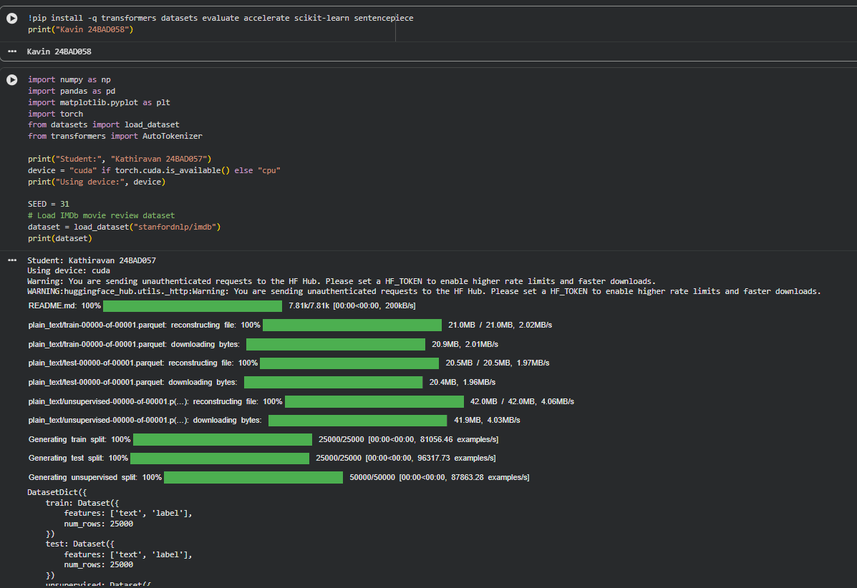

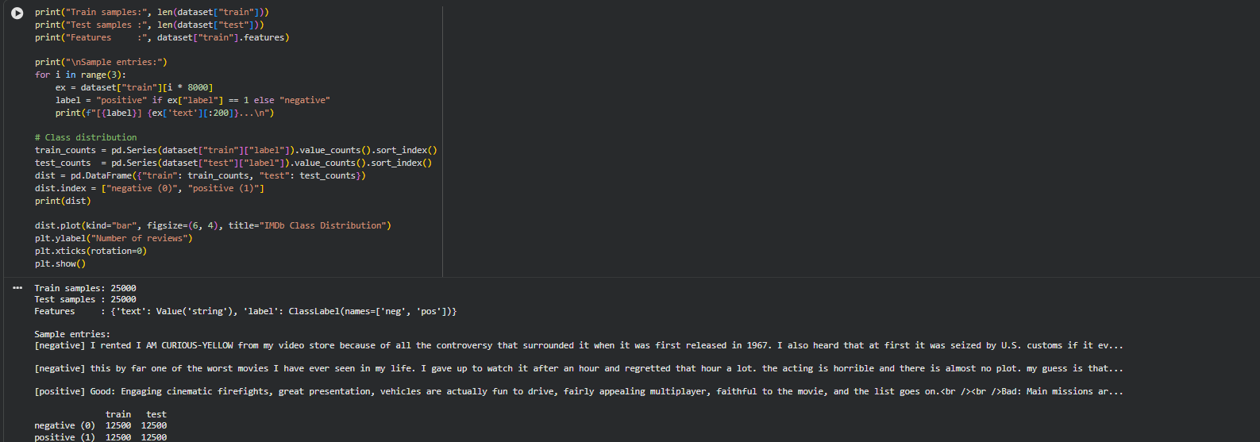

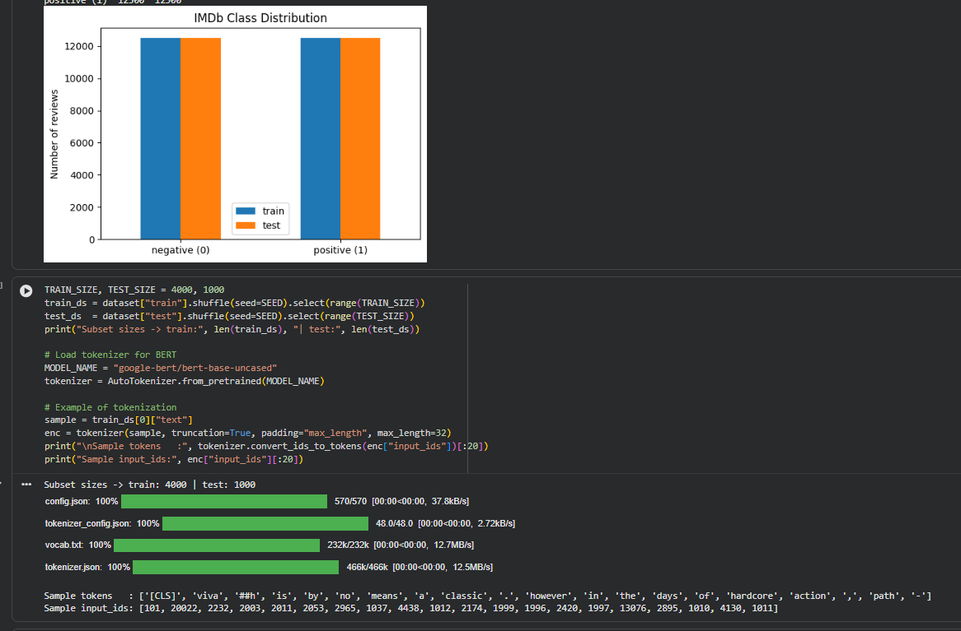

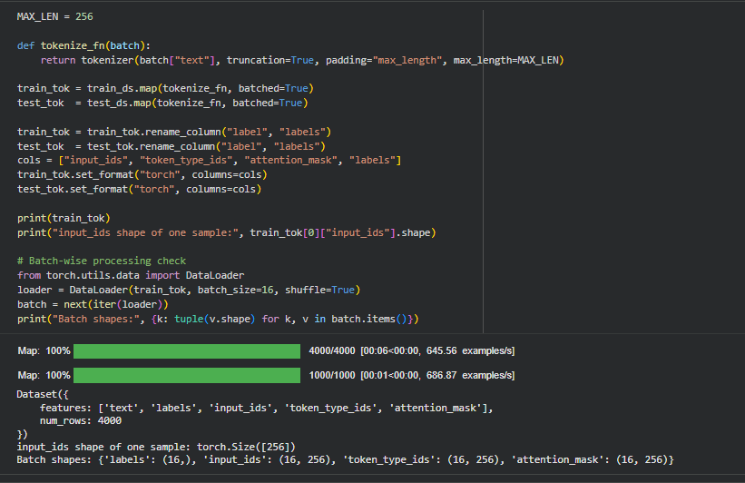

PART B: FINE-TUNING BERT FOR TEXT CLASSIFICATION
Perform the following tasks:
- Load a pretrained BERT model for sequence classification.
- Configure the model for the required number of classes.
- Prepare the tokenized training and testing datasets.
- Define the training parameters, including learning rate, batch size, and number of epochs.
- Fine-tune the BERT model using the training dataset.
- Evaluate the trained model using the testing dataset.
- Calculate appropriate performance metrics, such as accuracy, precision, recall, and F1-score.
- Test the model using new text inputs.
- Display the predicted class labels and corresponding evaluation results.
- Save the fine-tuned model and tokenizer.

CODE AND OUTPUT:

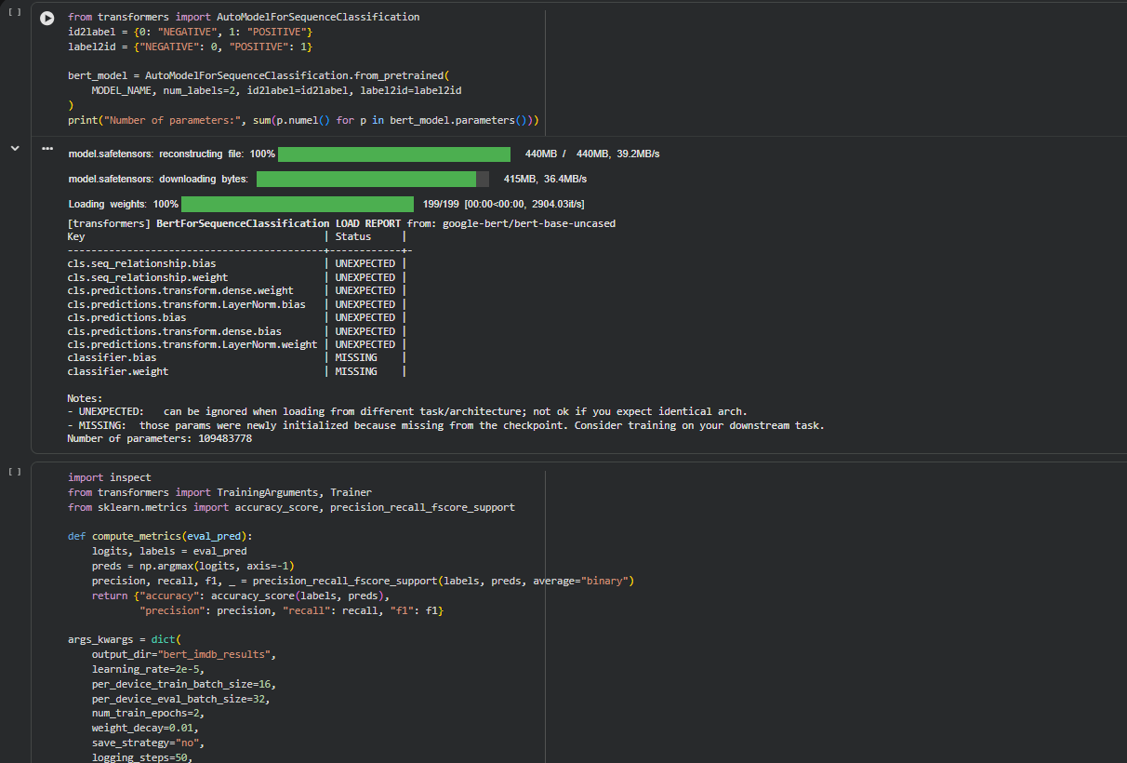

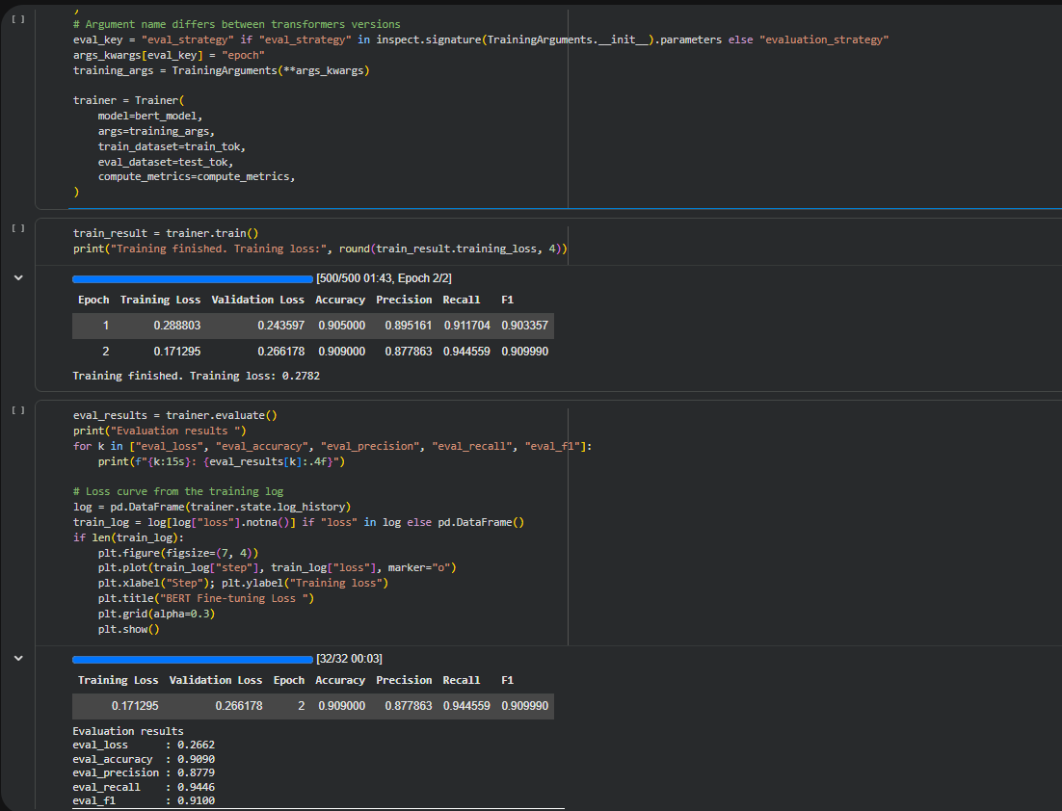

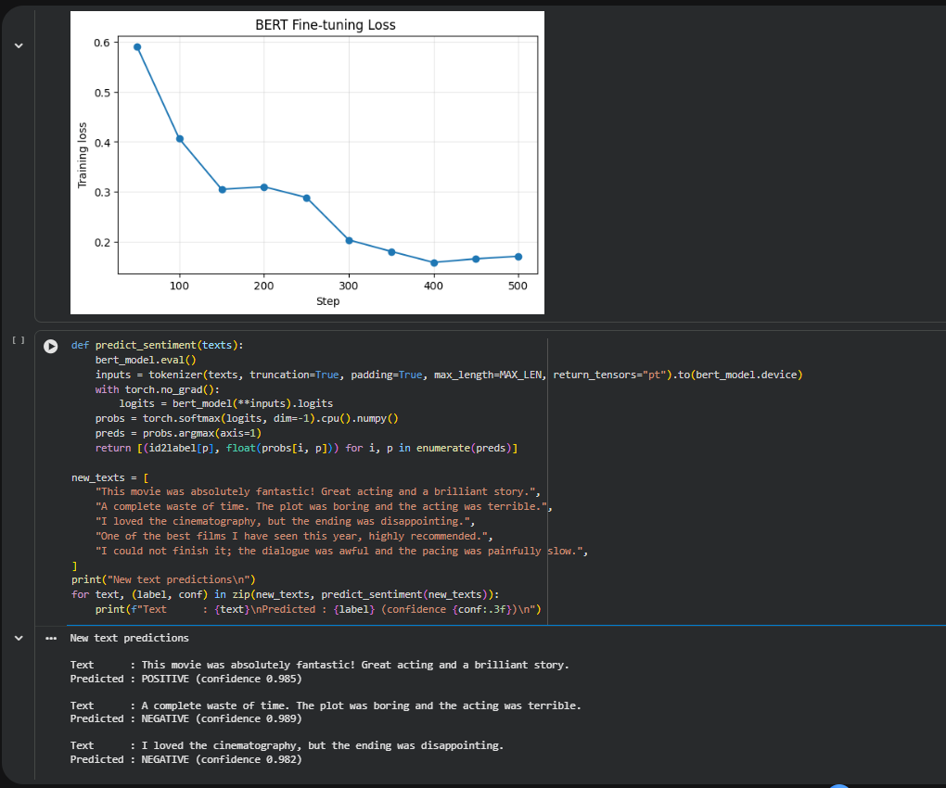

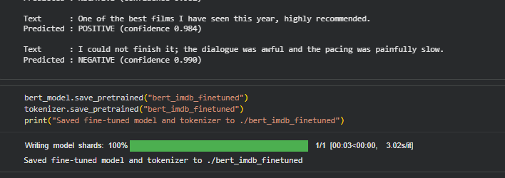
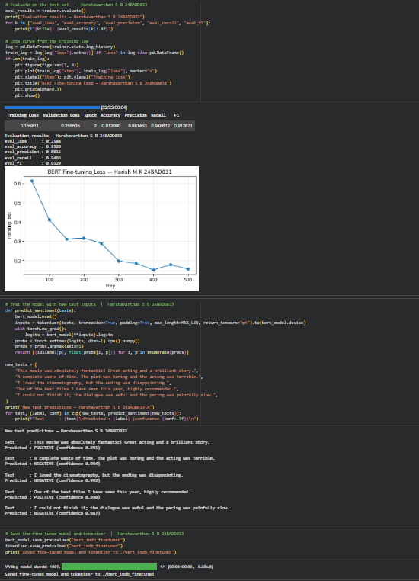

PART C: IMPLEMENTING A SEQUENCE-TO-SEQUENCE APPLICATION USING TRANSFORMERS
Perform the following tasks:
- Load a pretrained sequence-to-sequence Transformer model, such as T5-small.
- Load the corresponding tokenizer.
- Prepare a sample text input for the selected text generation task.
- Preprocess the input according to the model's requirements.
- Generate output text using the pretrained model.
- Apply appropriate generation parameters, such as maximum output length and beam search, where applicable.
- Display the input text and the generated output.
- Experiment with different input texts and generation settings.
- Observe how changes in the input and generation parameters affect the output.
- Save the generated outputs for further analysis.

CODE AND OUTPUT:

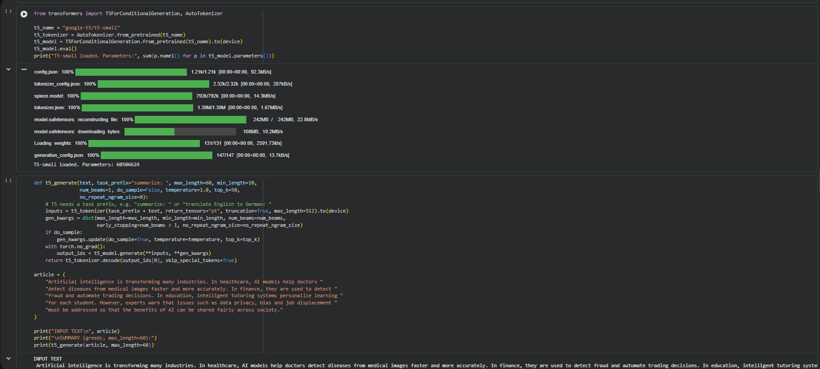

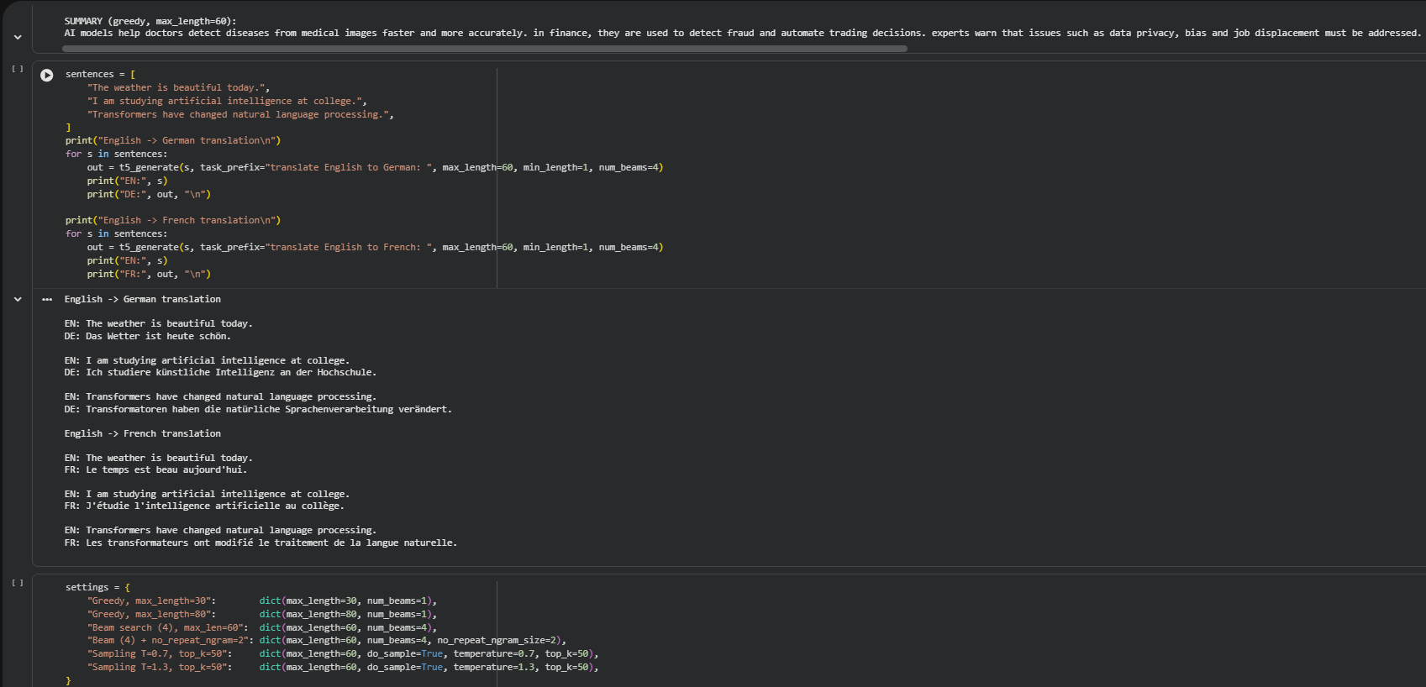

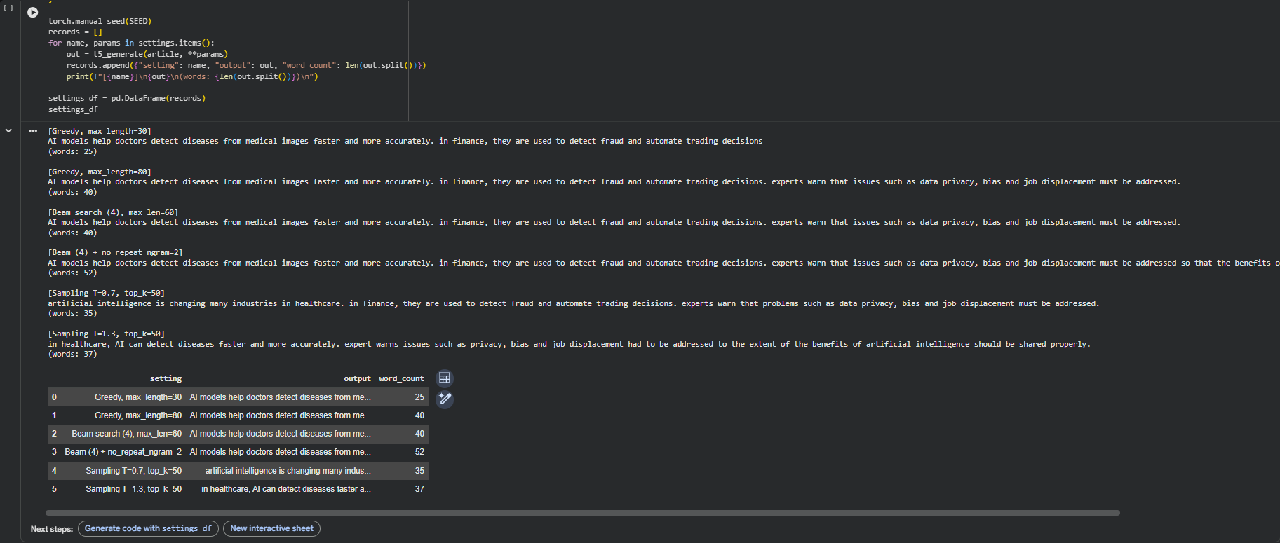

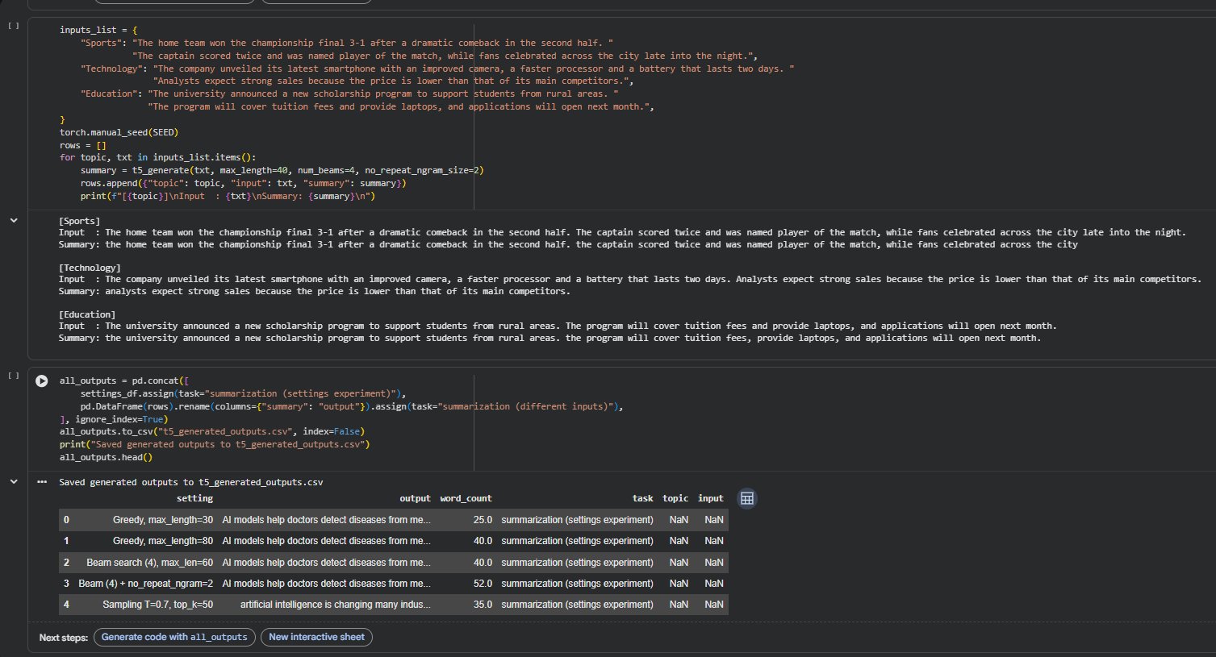

PART D: MODEL TESTING AND OUTPUT ANALYSIS
Perform the following tasks:
- Test the fine-tuned BERT model using sample positive and negative text inputs.
- Record the predicted class labels for the test inputs.
- Analyze the classification results using the selected evaluation metrics.
- Test the sequence-to-sequence model using different input texts.
- Compare the generated outputs for different inputs and generation settings.
- Examine the relevance, readability, and coherence of the generated text.
- Identify possible errors or limitations in the classification and generation outputs.
- Compare the applications of BERT-based classification and sequence-to-sequence text generation.
- Summarize the observations obtained from both models.

CODE AND OUTPUT:

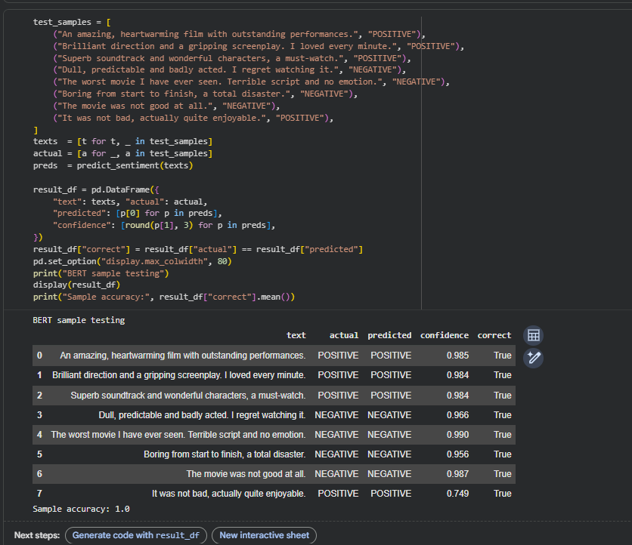

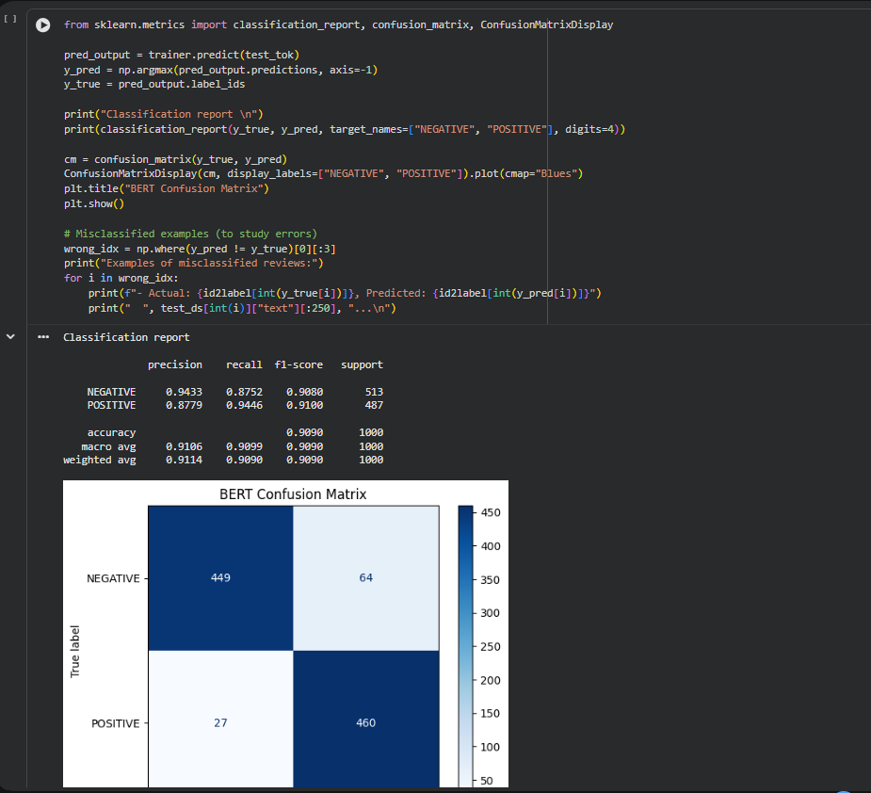
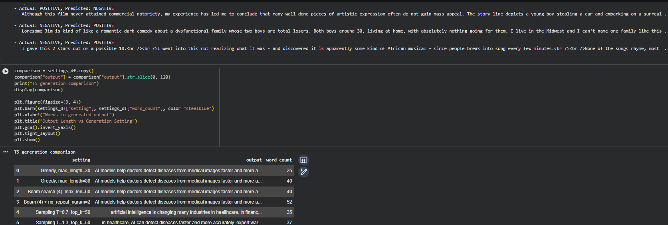

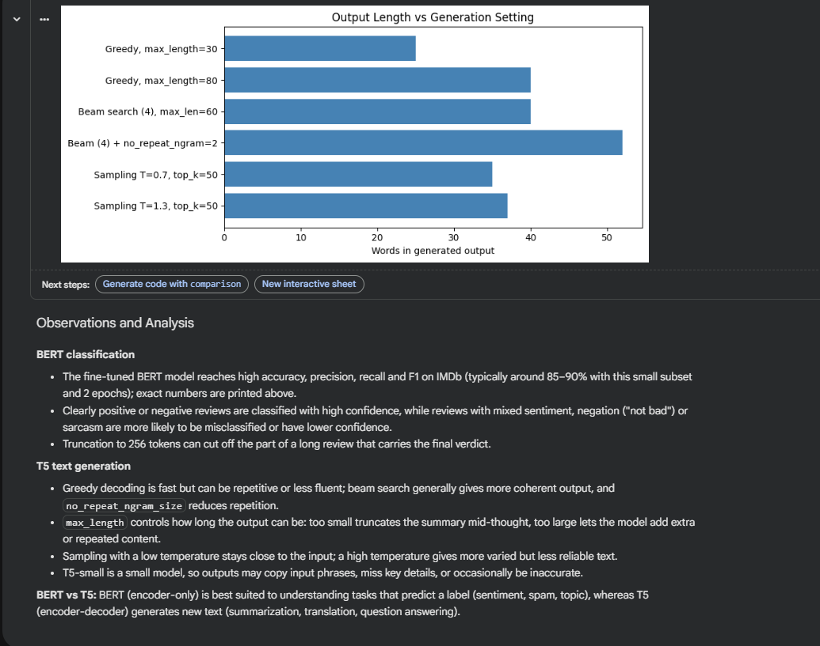

EXPECTED OUTCOME
Students will understand the architecture and applications of Transformer models in Natural Language Processing. They will learn to fine-tune a pretrained BERT model for text classification, preprocess textual data, and evaluate classification performance using appropriate metrics. Students will also develop a simple sequence-to-sequence text generation application using a pretrained Transformer model and analyze the quality and relevance of the generated outputs.

POST-LAB QUESTIONS (PROVIDE BRIEF ANSWERS TO THE FOLLOWING QUESTIONS)

- What is the role of BERT in text classification?
Ans: BERT converts the input text into context-aware vector representations. The representation of the [CLS] token is passed to a classification layer that outputs probabilities for each class, and the label with the highest probability is the prediction.
- Why is tokenization required before providing text to a Transformer model?
Ans: Models work on numbers, not raw text. The tokenizer splits text into tokens from the model's vocabulary (word pieces), maps them to integer IDs, adds special tokens ([CLS], [SEP]), and produces attention masks together with padding/truncation so that all sequences in a batch have the same length.
- What is the purpose of fine-tuning a pretrained BERT model?
Ans: To adapt BERT's general language understanding to a specific task and dataset (here IMDb sentiment). Fine-tuning improves accuracy on the target task while needing only a small labelled dataset and a short training time.
- Mention any two-evaluation metrics used for text classification.
Ans: Accuracy – fraction of all predictions that are correct. F1-score – harmonic mean of precision (correct positives among predicted positives) and recall (correct positives among actual positives). Precision and recall are also commonly used.
- What is the role of the encoder and decoder in a sequence-to-sequence Transformer?
Ans: The encoder reads the whole input text and builds contextual representations of it. The decoder generates the output tokens one by one, using the previously generated tokens and cross-attention to the encoder's representations to decide the next token.
- What is the difference between text classification and text generation?
Ans: Classification predicts a label from a fixed set of classes for a given text (encoder-only models such as BERT are typical). Generation creates a new sequence of words (encoder-decoder or decoder models such as T5 or GPT) and has no fixed set of outputs.
- How does the maximum output length affect text generation?
Ans: It caps the number of tokens the model may generate. A very small value cuts the output off, giving incomplete sentences or summaries; a very large value allows longer text but can add repetition or irrelevant content and takes more time. The length should suit the task (e.g. a short summary).
- Mention one real-world application of Transformer-based text classification and one application of text generation.
Ans: Classification: sentiment analysis of customer reviews (or spam e-mail detection). Generation: automatic text summarization of news articles (or machine translation, chatbots).

SUGGESTIONS FOR DATASETS & MODELS
Datasets:
- IMDb Movie Reviews – https://huggingface.co/datasets/stanfordnlp/imdb
- GLUE Benchmark – https://huggingface.co/datasets/nyu-mll/glue
- SST-2 Sentiment Classification – https://huggingface.co/datasets/nyu-mll/glue

Pretrained Models:
- BERT Base Uncased – https://huggingface.co/google-bert/bert-base-uncased
- T5-small – https://huggingface.co/google-t5/t5-small

ASSESSMENT
Description | Max Marks | Marks Awarded
Pre Lab Exercise | 5
In Lab Exercise | 10
Post Lab Exercise | 5
Viva | 10
Total | 30
Faculty Signature

